COMMERCIAL BUILDINGS ENERGY ASSESSMENT
MIDWEST INDUSTRIAL ASSESSMENT CENTER

 | 
Dr. Sanjeev Khanna
Director, Midwest Industrial Assessment Center
Professor, Mechanical & Aerospace Engineering, E3412 Lafferre Hall
University of Missouri
Columbia MO 65211, USA.
Ph: (573) 884-9109; email: Khannas@missouri.edu

Please submit this form as per the options below:

- Print and return this completed form by postal mail to:

Dr. Sanjeev Khanna
Department of Mechanical & Aerospace Engineering
E3412 Thomas and Nell Lafferre Hall,
University of Missouri
Columbia, MO 65211

Or,

- Return via email to address below:

khannas@missouri.edu

Contact Information

Company/Building Name: | _________________________________________________________
Mailing Address: | _________________________________________________________  _________________________________________________________
Street Address: | _________________________________________________________  _________________________________________________________
Contact Person: | _________________________________________________________
Title/Position: | _________________________________________________________
Phone: | _________________________________________________________
Email: | _________________________________________________________

Building Information

Building Name: | _________________________________________________________
Age of Building (years) | _________________________________________________________
Major Renovations (Date and Year) | _________________________________________________________  _________________________________________________________
Purpose of Building (Office, Warehouse etc.) | _________________________________________________________
Number of Floors | _________________________________________________________
Operating Hours (e.g., M-F 8-6, Sa 10-4) | _________________________________________________________
Total Occupants | _________________________________________________________
Building Automation  (HVAC controls, Light Controls etc.)  Any other information: | _________________________________________________________
Please check off the information that is being provided to IAC:
- Copy of 12 consecutive months of utility bills (electric, gas, water) Required
- Screen shot of EMCS or DDC control system Copies of previous energy audit reports.
- Copies of action plans or capital improvement plans Copies of any M&V plans.
- Copies of nameplates from HVAC and chiller equipment

Floor Name or Room Number | Activity Type (e.g., laboratory, executive offices, reception, etc.) | Floor Square Footage or % of Building Area (ft² or %) | Total Occupants | Daily Operational Hours or Percentage

Utility Information

Electricity | Utility Provider:  Annual Electric Consumption (kWh):  Annual Electric Cost ($):
Natural Gas | Utility Provider: Annual Gas Consumption (MMBtu/CCF):  Annual Gas Cost ($):
Water | Utility Provider: Annual Water Consumption (Gallons/CCF):  Annual Water Cost ($):
Sewer  (Is Sewer metered? Y/N) | Annual Sewer (Gallons/CCF):  Annual Sewer Cost ($):
(Please list any other fuels or specialty gases; e.g. coal, propane, CO₂, Nitrogen, etc.)

If using any other fuels/gases | Size of Tank:  Delivery Schedule  Total Cost

ADDITIONAL INFORMATION (provide to the best you can)

Lighting
Floor Name or Number | Location Description  (Near window, internal office, hallway, etc.) | Lamp Type | Ballast Type | Wattage | Total Number of Lamps | Number of hours lights are left on each day | Total kWh per Day | How are lights controlled?

Heating, Ventilation, and Air Conditioning Systems
What type of HVAC | What fuel type does this system use? | How is the |  | What type of chilled water system does the building have, where relevant (e.g., rotary screw chillers with cooling towers, etc.)? | How old |  |  | Do any of these systems have weather optimization sensors? If so, which systems and what brand of sensor?
system does the building |  | HVAC system | What are the |  | is the | What is the | What are the
have (e.g., constant |  | controlled (e.g., | operational |  | chilled | capacity of | operational
volume, multi-zone, VAV, |  | manually, DDC | setpoints? |  | water | the system? | setpoints?
etc.)? |  | system, etc.)? |  |  | system?

Who is responsible for managing and trouble-shooting the control system?

Are there any recurring or major occupant complaints about being too hot, too cold, etc.?

What energy efficiency efforts have been completed, started, or planned?

Are any capital improvement projects planned? If so, what are they and how will they affect the energy use of the building?

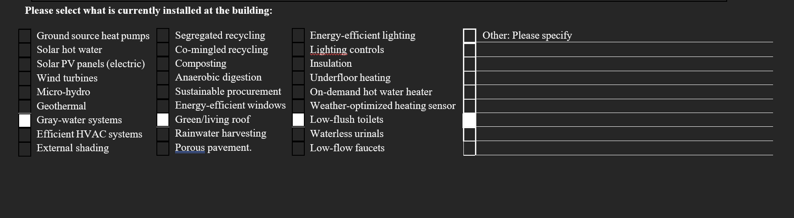

PLUG LOADS
Equipment Type | Manufacturer | Model or Size | Total Number | Wattage | Hours of Use per Day | Days of Use per Year | Total kWh | How is Equipment Controlled? | Description, Observations, or Notes
Vending machine
Computer
Printer
Computer Screen
Refrigerator

Please specify where you feel there is room for improvement either in efficiency measures or renewable energy technologies:

Building Envelope
Building Element | Condition  (Excellent, Good, Poor) | Type | Observations | Possible Energy Saving Opportunities
Windows
Doors
Roof
Walls
Floors

Operations and Management

Does the organization have an environmental policy?

Does the organization have an energy policy?

Does the organization have an environmental or energy manager?

Does the organization review these policies on an annual basis and establish reduction targets?

Do organizational stakeholders or shareholders value environmental and social responsibility?

BLANK PAGE FOR ANY OTHER RELEVANT INFORMTION.

